Table of Contents

OPPORTUNITY TO EXPLORE 3

SCOPE STATEMENT 3

PROJECT CHARTER: UPI SYSTEMS 6

BUSINESS ANALYSIS APPROACH TEMPLATE 7

METHODOLOGY 7

DOCUMENTATION FORMALITY 8

PROCESS TO FOLLOW 8

TIMING OF BUSINESS ANALYSIS WORK AND ACTIVITIES 11

BUSINESS STAKEHOLDER ENGAGEMENT PLAN 12

REFERENCES 14

# OPPORTUNITY TO EXPLORE

Scotiabank consideration of the adoption of the Unified Payments Interface (UPI) marks an advancement in payment technology. Integrating UPI offers a practical payment system that meets the changing expectations of customers. By providing time and interoperable solutions, it strengthens Scotiabank’s advantage and appeals to tech-savvy clients who value faster transactions. In addition to enhancing the banking experience, UPI enables border transactions and enhances security, reinforcing Scotiabank’s reputation as an innovative financial institution (Jacob, 2021).

Before implementing UPI, it is crucial to conduct an analysis that evaluates factors such as cost-benefit, market demand, risks, and compliance with regulations. Lastly, the adoption of UPI represents progress in technology and customer-centric banking. By embracing payments, improving efficiency, and adapting to market dynamics, Scotiabank positions itself as a thinking industry leader committed to prioritizing customer satisfaction. (Jacob, 2021).

# SCOPE STATEMENT

|  |
| --- |
| **Project Title: Assignment-2**  **Date:18-09-2023** **Prepared by:** Yash Surti |
| **Project Justification:** It is crucial for financial institutions to embrace payment technologies in order to thrive and stay up to date in today's changing landscape. In this project explanation, we will delve into Scotiabank's implementation of the Unified Payments Interface (UPI) payment system. Let us discuss why embracing this system is beneficial and necessary. (Unified Payments Interface, 2023)  Advancements in technology are propelling the sector forward in today's world. Scotiabank's decision to adopt the UPI payment system aligns perfectly with its commitment to being at the forefront of innovation. (Unified Payments Interface, 2023)  The financial sector has witnessed a shift in consumer preferences towards electronic payment alternatives. The growth of banking and online transactions has generated a need for safe and practical payment methods. Recognizing the urgency of this paradigm shift, Scotiabank understands the importance of addressing it in order to maintain its edge and meet client expectations. (Unified Payments Interface, 2023)  Benefits for Practitioners and Scholars.  Enhanced Customer Experience: By deploying the UPI payment system, Scotiabank is creating an effective and secure payment environment that will greatly benefit its customers. This improved customer experience will result in increased happiness, loyalty, and retention. (Unified Payments Interface, 2023)  Competitive Advantage: Embracing UPI sets Scotiabank apart from its competitors by showcasing its dedication to innovation. (Unified Payments Interface, 2023) This competitive edge will drive growth by attracting customers and keeping existing ones. In terms of cost-effectiveness, UPI transactions offer an alternative compared to traditional methods, like checks and wire transfers. By reducing costs, Scotiabank can enhance productivity and profitability. (Unified Payments Interface, 2023) |
| **Product Characteristics and Requirements:**  **Interoperability:**  Characteristics: The UPI payment system integration will be planned to connect with different digital payment platforms in an effortless manner, ensuring interoperability with various banking systems and payment apps.  Requirements: The system must provide interoperability with other banks and financial institutions that use the UPI standard. (Gochhwal, 2017)  **Security and Compliance:**  Characteristics: To enable secure transactions, the payment system will make use of strong encryption, authentication, and fraud detection mechanisms.  Requirements: It must adhere to regulations set forth by the appropriate financial authorities, as well as industry standards for data security and client protection. (Gochhwal, 2017)  **User-Friendly Interface:**  Characteristics: The UPI system will have an intuitive, user-friendly user interface that is accessible on both mobile and web platforms.  Requirements: Customers must have a seamless and trouble-free experience thanks to features like biometric verification, account linkage, and transaction history tracking, among others. (Gochhwal, 2017)  **Transaction Speed and Reliability:**  Characteristics: The UPI payment system ought to provide lowest latency real-time transaction processing.  Requirements: Its processing of payments must be quick and dependable, with no downtime or interruption of service. (Gochhwal, 2017) |
| **Product User Acceptance Criteria:**  **Scenario:** The scenario is that Scotiabank is implementing the UPI payment system.  **Given:**  -Given that a client has a Scotiabank account.  -Given that the customer has a UPI payment system registration.  -Given that the client has access to the web-based platform or a mobile device that is compatible. (Rao, 2023)  **When:**  -When a user begins a UPI transaction via the Scotiabank website or mobile app.  -When a customer chooses a recipient and fills out the transaction information.  -When the customer validates the transaction using the necessary authentication (e.g., PIN, biometric, OTP). (Rao, 2023)  **Then:**  -Then, UPI transaction can be handled in real-time.  -Then, to safeguard the customer's financial information, the transaction will be securely encrypted.  -Then, the consumer will thereafter get prompt confirmation of the transaction's success.  -Then, recent transactions will be updated in the transaction history.  -Then, the customer can review the transaction details, including the recipient information and transaction amount.  -Then, the transaction, along with any fees or currency changes related to it, will be shown in the customer's account balance.  -Then, customers have access to a transaction receipt for their records that contains a special transaction reference number.  -Then, the customer will be informed of exchange rates and any associated fees before confirming a cross-border transaction.  -Then, the customer will have access to a helpful customer service system via chat, email, or phone in case they run into any problems or anomalies with the transaction. (Rao, 2023)  **7IProject management-related deliverables**   |  |  | | --- | --- | | * Business case-Not Completed | * Cost baseline- Not Completed | | * Charter- Completed | * Status reports-Completed | | * Team contract-Completed | * Final project- Not Completed | | * Scope statement- Completed | * Presentation- Not Completed | | * WBS- Not Completed | * Final project report- Not Completed | | * Schedule- Not Completed | * Lessons-learned report- Not Completed |   **Product-related deliverables:** research reports, design documents, software code, hardware, etc.   |  |  | | --- | --- | | * Research Reports-Completed | * Design Documents- Not Completed | | * Software Code- Not Completed | * Hardware- Not Completed | |

# PROJECT CHARTER: UPI SYSTEMS

|  |  |  |  |
| --- | --- | --- | --- |
| **Project Title**: Assignment - 2 | | | |
| **Project Start Date:** September 12, 2023 **Projected Finish Date:** September 23, 2023 | | | |
| **Budget Information: $5.4 Billion Dollars** | | | |
| **Project Manager:** Abimbola Sanni, 513 (226) 5678, asanni5932@conestogac.on.ca | | | |
| **Project Objectives:**   * Successfully integrated the UPI payment system into Scotiabank's infrastructure.   Our customers have quick, guarded and fool-proof payment conditions.   * Achieve competitive advantage in the financial sector through innovation. * Try to decrement operating costs and increment productivity with better interest. | | | |
| **Success Criteria:**  The main goals of the UPI project include improving the user experience, ensuring that transactions are reliable, reducing operational costs, expanding Scotiabank's market presence and completing the project on time and within budget. | | | |
| **Approach**   * We will Begin by assembling a diverse project team and writing a detailed charter. * Once approved, we will commence thorough planning, including risk and communication strategies. * We will ensure we work closely with all the parties to thoroughly understand their needs, which will guide UPI's design, development, and rigorous testing. * After approval has been gotten and signed off, train employees, inform customers, and deploy the system in phases. * Continuously evaluate performance and adjust based on feedback until project closure. | | | |
| **Roles and Responsibilities** | | | |
| ***Name*** | ***Signature*** | ***Position*** | ***Contact Information*** |
| **Abimbola Sanni** |  | **Project Manager** | **513 (226) 5678** |
| **Bhupinder Singh** |  | **Assistant Project Manager** | **553 (535) 6899** |
| **Geethu Joy** |  | **Business Analyst** | **226 (345) 5454** |
| **Maheep Kaur** |  | **Business Analyst** | **434 (464) 6445** |
| **Yash Surti** |  | **Business Analyst** | **123 (464) 6675** |

# BUSINESS ANALYSIS APPROACH TEMPLATE

## 

## METHODOLOGY

Selecting a methodology and best planning approach for our business analysis activities is essential to align with the project's objectives. Given the project's complexity, we decided to use the Scrum Framework. Scrum is an agile framework for project management that emphasizes teamwork, accountability, and iterative progress toward a well-defined goal (Lutkevich, 2021). It helps teams structure and manage their work through a set of values, principles, and practices. We chose Scrum based on factors like it is iterative and incremental, customer-centric, highlights collaboration, is transparent, mitigates risk efficiently and provides opportunities for continuous learning and improvement.

(optimmus.io)

## DOCUMENTATION FORMALITY

Within the Scrum framework, we harmoniously blend formal and informal documentation styles. Our heart lies in dynamic, evolving documentation sculpted iteratively as our project unfolds. While post-implementation gives rise to more formal records, most insights stem from day-to-day interactions: casual emails, Teams chats, or Zoom sessions with key players like our Project Manager or Domain Expert. Even though we often rely on online sources or informal questionnaires for quick insights, formal annual reports will not be ignored. We will leverage tools like MS Project, Jira, and Visio to help deliver our project.

## PROCESS TO FOLLOW

**Scotia UPI System Requirement Elicitation:**

Eliciting requirements is an important phase in creating the "Scotia UPI System," it ensures that the product meets the requirements and desires of users, banking organizations, legislators, and other stakeholders. The following methods are specific to acquiring needs for the new UPI system:



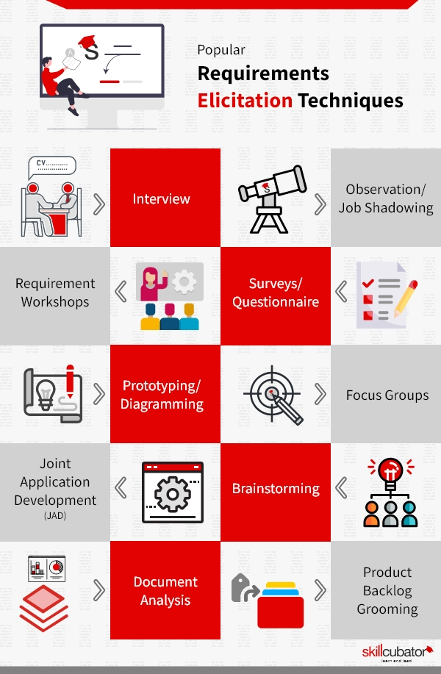

(skillcubator.com)

* **Brainstorming:**
* Plan brainstorming meetings featuring various individuals, such as software developers, finance specialists, Interact e-transfer usage, UPI consumers, and security specialists.
* **Survey:**
* Create a detailed survey targeted at a specific group, encompassing stakeholders in the finance sector and present and future UPI users in Canada.
* **Interviews:**
* Perform one-on-one interviews with significant stakeholders, including bank officials, prospective customers, governmental legislators, and cybersecurity researchers.
* Ask them open-ended questions to learn more about their wants, requirements, and issues with the Scotia UPI System.
* **User Observation:**
* Monitor actual client use of the Scotia UPI System over their financial transactions or in supervised evaluations of usability settings.
* Keep track of user activities, problems, and engagement with different system functions.
* **Focus Group:**
* Gather a varied sample of prospective Scotia UPI System users, considering their backgrounds and use cases.
* **Approach analysis**
* To find standards and breakthroughs in electronic payment solutions, do a detailed investigation of the UPI systems that are now in use worldwide, both rivals and sector leaders.

MEETINGS:

These are some of the meetings that will be held during this project

PROJECT PLAN

The project schedule for adopting the Scrum approach to deploy Scotia Bank's UPI (Unified Payments Interface) system is set up to last approximately three months for proof of content (Demo), broken into one-week sprints. We will develop the product backlog, define the project's goals, and fill critical positions throughout the beginning phase.

The multi-functional Scrum team will design and test the UPI system during the following planning and execution stages while complying with the Definition of Done. Retrospective meetings and sprint reviews will support continual progress.

To account for changing requirements, the backlog will be continually refined. Quality assurance and extensive testing emphasizing security and conformity will be essential.

After deployment, there will be user training and close post-launch monitoring. Any problems will be fixed, and user input will be considered in the next sprints. Project closure will also include retrospectives, the preservation of documents, and future maintenance planning. The Scrum methodology provides adaptation and reactivity during the project lifecycle and seeks to produce a robust UPI system that improves consumer interactions and facilitates digital payments.

The following tasks are common for each sprint and will help us to track and work on user stories or iterative tasks. Consider sprint going for one week; below is the project plan for the Scotia UPI system.

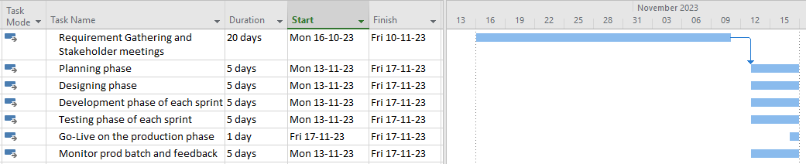

## TIMING OF BUSINESS ANALYSIS WORK AND ACTIVITIES

START

* **Phase 1: Preliminary Research and Data Gathering** - Understanding the current state of Scotia Bank and its digital payment systems. It is critical to gather information about the company its goals to provide a foundation for the project. (2 weeks)
* Reading about the company
* Interview the persons/bank
* Interview with stakeholders

MIDDLE

* **Phase 2: Requirements Analysis, Detailed Analysis, and Planning** – During this phase, we will define high-level requirements, detailed analysis of all aspects of the project to identify the market, financial, and customer needs and user stories, and create a backlog list. Prioritize requirements, plan sprints, and prepare for agile development. (3 weeks)
* Gap analysis
* Financial analysis
* Market analysis
* Need identification analysis
* Resource analysis
* Sprint backlogs (High-level data to create a plan for overall project execution, not the detailed sprint, which is ongoing throughout the project.
* Roadblocks (Ongoing throughout the project)
* **Phase 3: Development and testing:** The processes involved in this phase will be carried out throughout the project. It will be executed in iterative sprints of 1 week. Post-development, it will be followed by quality assurance and testing. (5 weeks)
* Process modeling and mapping
* Daily standups
* Sprint
* Quality assurance & testing

END

* **Phase 4: Implementation, User Training, Documentation, and Closure** – In this phase, UPI system will be implemented, and Training sessions will be planned and conducted. All interactions, developments, all details will be documented and formally close the project. (2 weeks)
* User training and support
* Documentation and reporting
* Project closure

# BUSINESS STAKEHOLDER ENGAGEMENT PLAN

**RACI CHART**

# REFERENCES

Gochhwal, R. (2017, January 1). *Unified Payment Interface—An Advancement in Payment Systems*. American Journal of Industrial and Business Management; Scientific Research Publishing. <https://doi.org/10.4236/ajibm.2017.710084>

Jacob, H. S. M. E. (2021). *Unified Payment Interface (UPI)—A Critical Review Of Benefits And Challenges Of Advanced Payment Systems*. <https://www.webology.org/abstract.php?id=2638>

Lutkevich, B. (2021, October 28). *What is Scrum?*. Software Quality. <https://www.techtarget.com/searchsoftwarequality/definition/Scrum>

OPTIMMUS. (2022, November 8). *What is Scrum? A quick guide and cheat sheet to the scrum software development process*. https://optimmus.io/what-is-scrum-the-ultimate-guide-to-the-scrum-software-development-process/

Rao, A. (2023, September 1). *UPI goes global: The past, present & future of Indias payments platform*. WION. <https://www.wionews.com/business-economy/upi-goes-global-the-past-present-future-of-indias-payments-platform-630396>

Skillcubator. (2023, February 28). *Requirements elicitation technique (Ret) : 10+ effective ret*. https://skillcubator.com/requirements-elicitation-techniques/

*Unified Payments Interface*. (2023, September 14). Wikipedia. <https://en.wikipedia.org/wiki/Unified_Payments_Interface>